1. <http://localhost:51712/UserRestService.svc/Users>

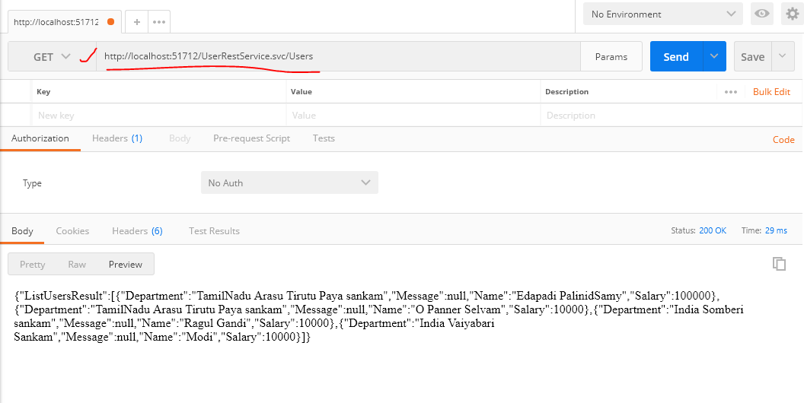

1. <http://localhost:51712/UserRestService.svc/Users/Modi>

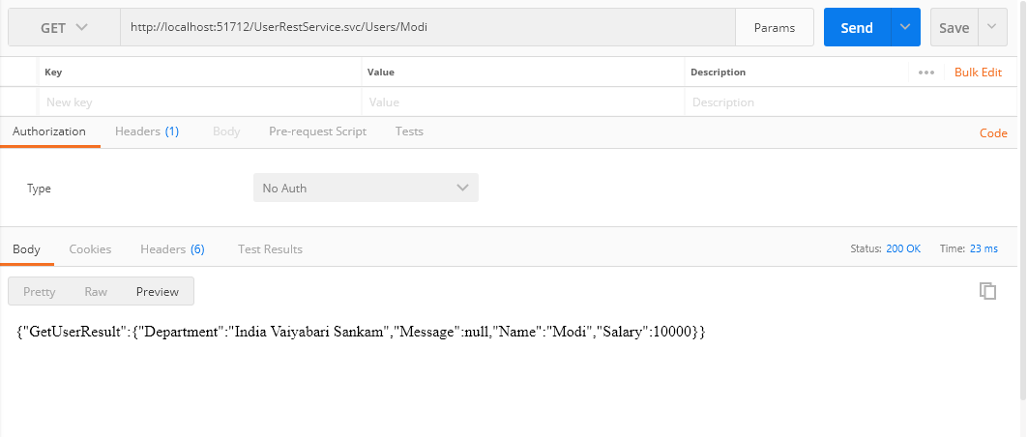

1. <http://localhost:51712/UserRestService.svc/Users/Create>

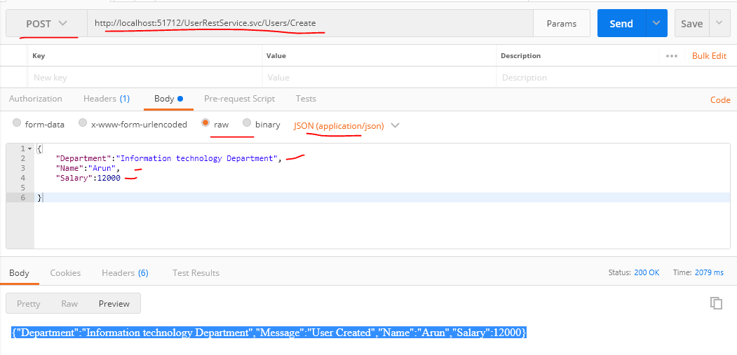

1. <http://localhost:51712/UserRestService.svc/Users/Update>

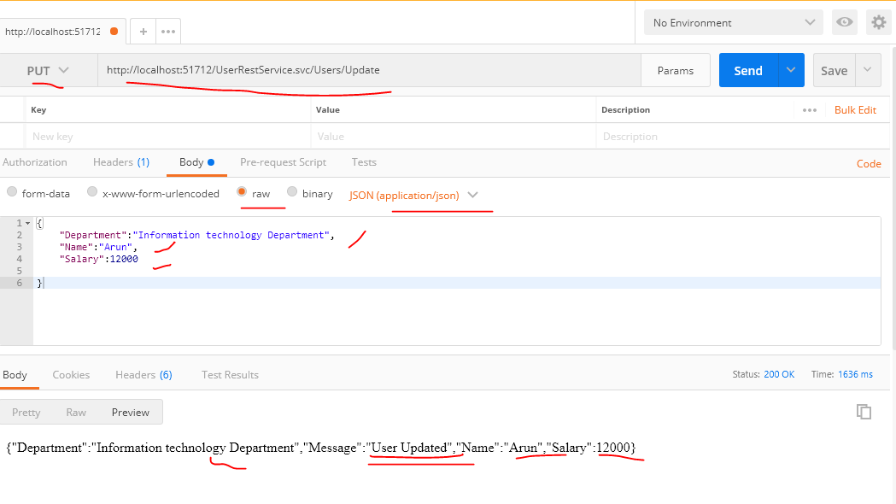

1. <http://localhost:51712/UserRestService.svc//Users/Delete>

